Gradians
# Source: AI Source: Provided by: [Data Path: Persons Table -> ID Column: 1, Name_En Column: Motasem Essam] -> From: [ChatGPT] on [7/25/2026]
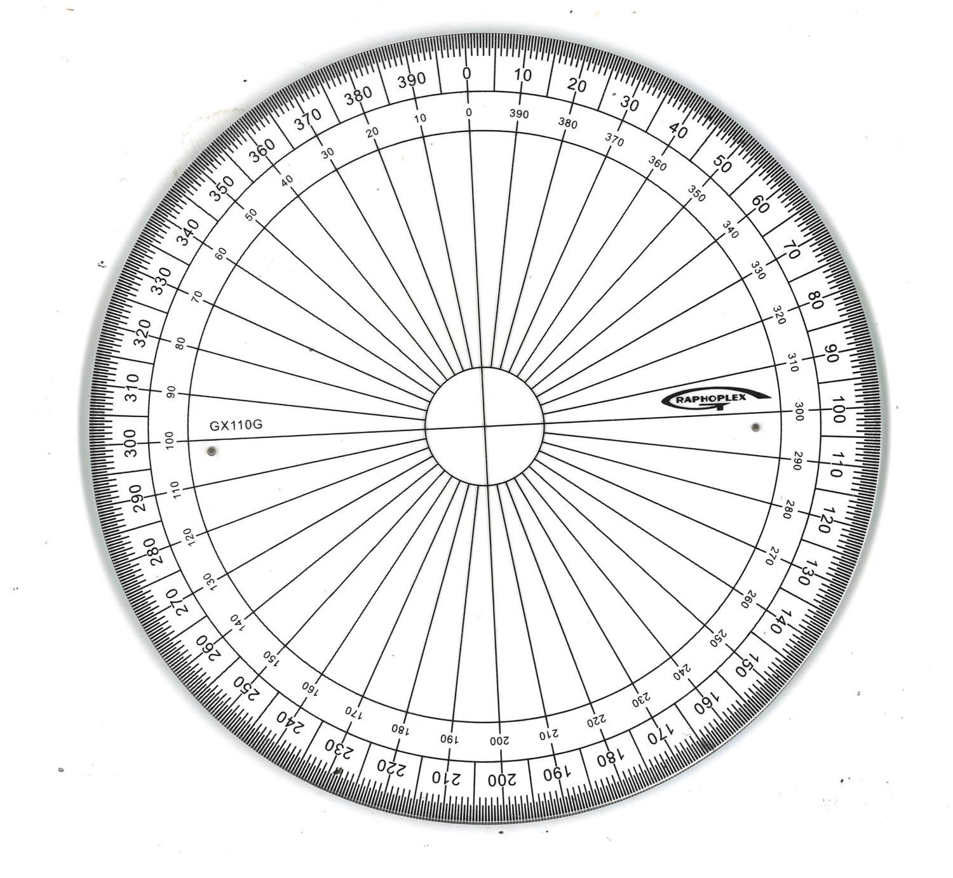
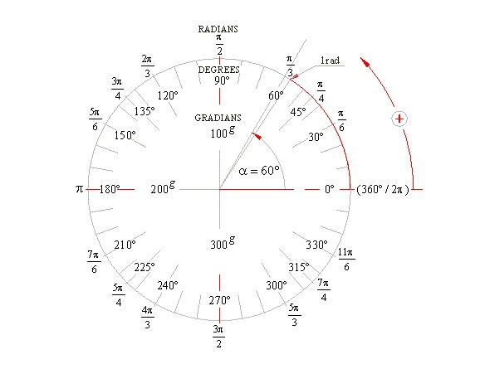
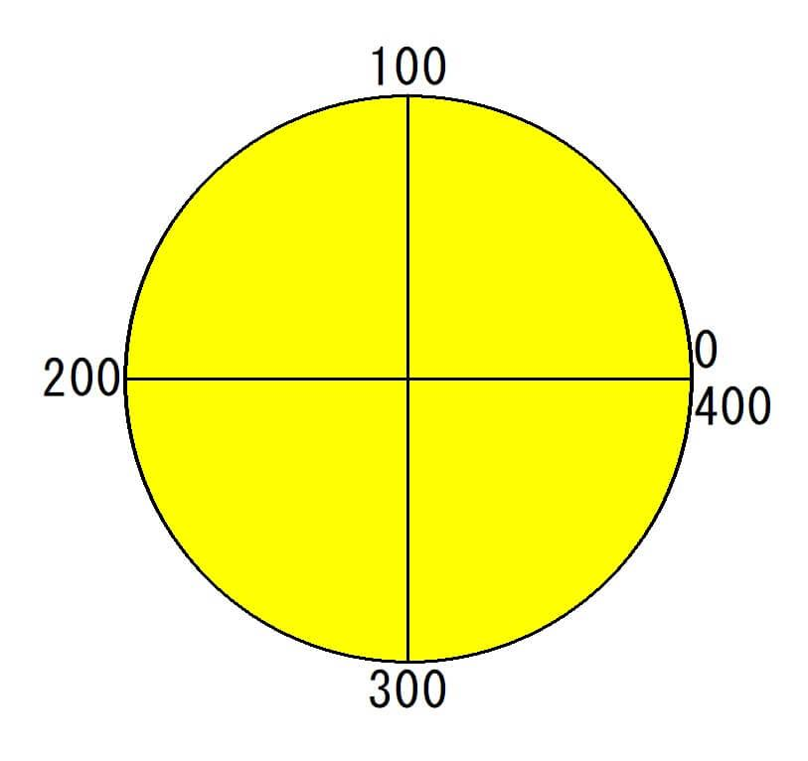
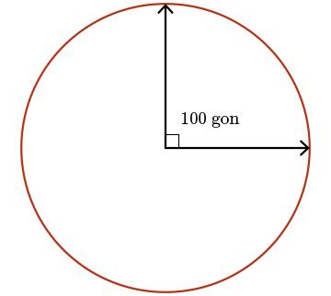
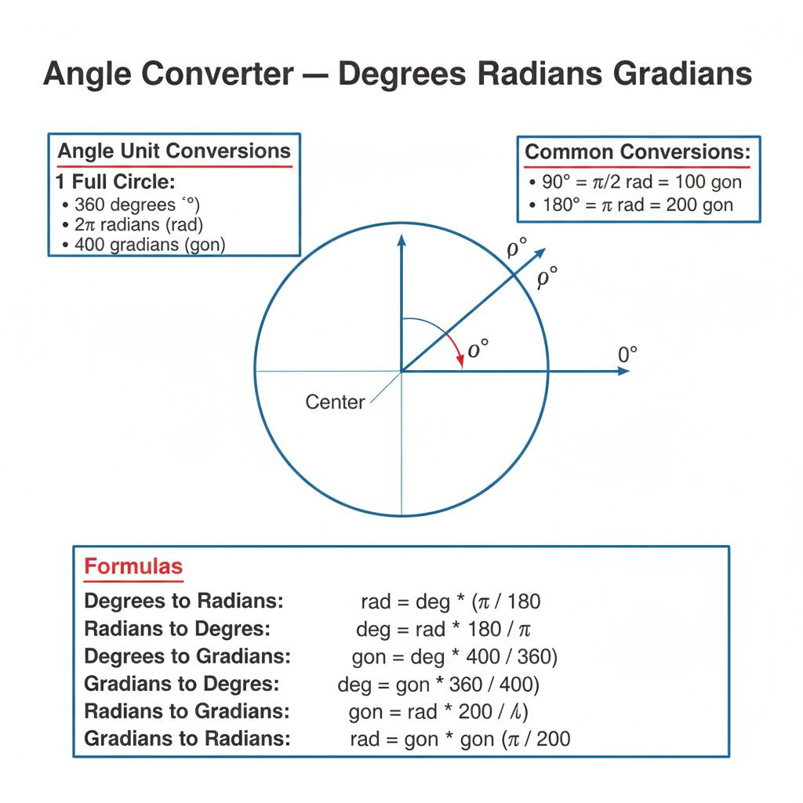
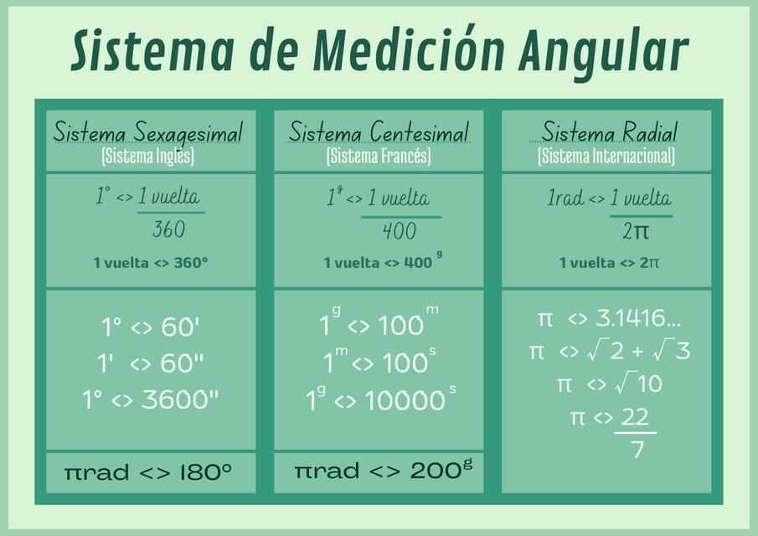

Definition
# Source: AI Source: Provided by: [Data Path: Persons Table -> ID Column: 1, Name_En Column: Motasem Essam] -> From: [ChatGPT] on [7/25/2026]
A Gradian (also called a Gon, Grade, or Grad) is a unit of angle measurement in which a full rotation is divided into 400 equal parts.
Unlike degrees, which divide a circle into 360 parts, gradians divide it into 400 parts, making right angles equal to exactly 100 gradians.
The gradian is commonly used in surveying, geodesy, civil engineering, and some European mapping systems.

Symbols
# Source: AI Source: Provided by: [Data Path: Persons Table -> ID Column: 1, Name_En Column: Motasem Essam] -> From: [ChatGPT] on [7/25/2026]
The gradian may be represented by:
- gon (SI-accepted symbol)
- grad
- g
Examples:
$$50 \text{gon} \\ 100 \text{gon}$$

Historical Background
# Source: AI Source: Provided by: [Data Path: Persons Table -> ID Column: 1, Name_En Column: Motasem Essam] -> From: [ChatGPT] on [7/25/2026]
The gradian was introduced during the French Revolution as part of the decimal metric system.
Its purpose was to simplify angle calculations by using a decimal-based system rather than the traditional 360-degree system.

Full Rotation
# Source: AI Source: Provided by: [Data Path: Persons Table -> ID Column: 1, Name_En Column: Motasem Essam] -> From: [ChatGPT] on [7/25/2026]
One complete revolution equals:
$$400 \text{gon}$$
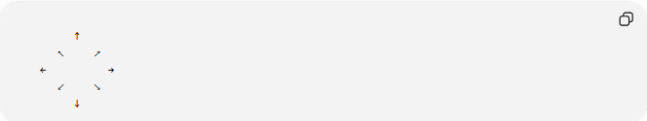
↑
↖ ↗
← →
↙ ↘
↓

Relationship with Degrees
# Source: AI Source: Provided by: [Data Path: Persons Table -> ID Column: 1, Name_En Column: Motasem Essam] -> From: [ChatGPT] on [7/25/2026]
A full circle:
$$400 \text{gon}={360}^{∘}$$
Therefore:
$$100 \text{gon}={90}^{∘}$$

Relationship with Radians
# Source: AI Source: Provided by: [Data Path: Persons Table -> ID Column: 1, Name_En Column: Motasem Essam] -> From: [ChatGPT] on [7/25/2026]
A full circle is also:
$$2π \text{radians}=400 \text{gon}$$

Conversion Formulas

Degrees → Gradians
# Source: AI Source: Provided by: [Data Path: Persons Table -> ID Column: 1, Name_En Column: Motasem Essam] -> From: [ChatGPT] on [7/25/2026]
$$θ_{\text{gon}}=θ_{\text{deg}}×\frac{400}{360}=θ_{\text{deg}}×\frac{10}{9}$$

Gradians → Degrees
# Source: AI Source: Provided by: [Data Path: Persons Table -> ID Column: 1, Name_En Column: Motasem Essam] -> From: [ChatGPT] on [7/25/2026]
$$θ_{\text{deg}}=θ_{\text{gon}}×\frac{360}{400}=θ_{\text{gon}}×\frac{9}{10}$$

Radians → Gradians
# Source: AI Source: Provided by: [Data Path: Persons Table -> ID Column: 1, Name_En Column: Motasem Essam] -> From: [ChatGPT] on [7/25/2026]
$$θ_{\text{gon}}=θ_{\text{rad}}×\frac{200}{π}$$

Gradians → Radians
# Source: AI Source: Provided by: [Data Path: Persons Table -> ID Column: 1, Name_En Column: Motasem Essam] -> From: [ChatGPT] on [7/25/2026]
$$θ_{\text{rad}}=θ_{\text{gon}}×\frac{π}{200}$$

Common Angle Equivalents
# Source: AI Source: Provided by: [Data Path: Persons Table -> ID Column: 1, Name_En Column: Motasem Essam] -> From: [ChatGPT] on [7/25/2026]
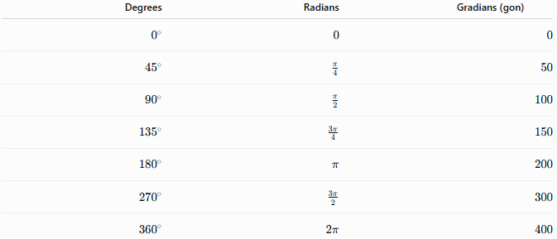
Degrees | Radians | Gradians (gon)
$$0^{∘}$$ | $$0$$ | $$0$$
$${45}^{∘}$$ | $$\frac{π}{4}$$ | $$50$$
$${90}^{∘}$$ | $$\frac{π}{2}$$ | $$100$$
$${135}^{∘}$$ | $$\frac{3π}{4}$$ | $$150$$
$${180}^{∘}$$ | $$π$$ | $$200$$
$${270}^{∘}$$ | $$\frac{3π}{2}$$ | $$300$$
$${360}^{∘}$$ | $$2π$$ | $$400$$

Examples
# Source: AI Source: Provided by: [Data Path: Persons Table -> ID Column: 1, Name_En Column: Motasem Essam] -> From: [ChatGPT] on [7/25/2026]
Example 1
Convert:
$${90}^{∘}$$
to gradians.
$$90×\frac{10}{9}=100$$
Answer:
$$\boxed{100 \text{gon}}$$

Example 2
Convert:
$$80 \text{gon}$$
to degrees.
$$80×\frac{9}{10}={72}^{∘}$$

Example 3
Convert:
$$200 \text{gon}$$
to radians.
$$200×\frac{π}{200}=π$$
Answer:
$$\boxed{π \text{radians}}$$

Advantages of Gradians
# Source: AI Source: Provided by: [Data Path: Persons Table -> ID Column: 1, Name_En Column: Motasem Essam] -> From: [ChatGPT] on [7/25/2026]
Gradians:
- Use a decimal system.
- Make right angles exactly:
$$100 \text{gon}$$
- Simplify calculations in surveying.
- Fit naturally with metric-based measurements.

Limitations
# Source: AI Source: Provided by: [Data Path: Persons Table -> ID Column: 1, Name_En Column: Motasem Essam] -> From: [ChatGPT] on [7/25/2026]
Gradians:
- Are less commonly used than degrees.
- Are rarely used in trigonometry and calculus.
- Are not the standard unit in most countries.
- Usually require conversion when working with scientific formulas.

Applications
# Source: AI Source: Provided by: [Data Path: Persons Table -> ID Column: 1, Name_En Column: Motasem Essam] -> From: [ChatGPT] on [7/25/2026]
Gradians are primarily used in:
- Surveying
- Geodesy
- Civil Engineering
- Cartography
- Mapping
- Land Measurement
- Construction
- Topographic Analysis

Comparison of Angle Units
# Source: AI Source: Provided by: [Data Path: Persons Table -> ID Column: 1, Name_En Column: Motasem Essam] -> From: [ChatGPT] on [7/25/2026]
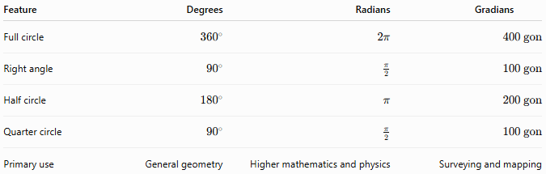
Feature | Degrees | Radians | Gradians
Full circle | $${360}^{∘}$$ | $$2π$$ | $$400 \text{gon}$$
Right angle | $${90}^{∘}$$ | $$\frac{π}{2}$$ | $$100 \text{gon}$$
Half circle | $${180}^{∘}$$ | $$π$$ | $$200 \text{gon}$$
Quarter circle | $${90}^{∘}$$ | $$\frac{π}{2}$$ | $$100 \text{gon}$$
Primary use | General geometry | Higher mathematics and physics | Surveying and mapping

Key Points
# Source: AI Source: Provided by: [Data Path: Persons Table -> ID Column: 1, Name_En Column: Motasem Essam] -> From: [ChatGPT] on [7/25/2026]
- A Gradian (Gon) divides a circle into:
$$400$$
equal parts.
- Relationships:
$$400 \text{gon}={360}^{∘}=2π \text{radians}$$
- Right angle:
$$100 \text{gon}$$
- Conversion:
Degrees to gradians:
$$θ_{\text{gon}}=θ_{\text{deg}}×\frac{10}{9}$$
Gradians to degrees:
$$θ_{\text{deg}}=θ_{\text{gon}}×\frac{9}{10}$$

Conclusion
# Source: AI Source: Provided by: [Data Path: Persons Table -> ID Column: 1, Name_En Column: Motasem Essam] -> From: [ChatGPT] on [7/25/2026]
A Gradian (Gon) is a decimal-based unit for measuring angles in which a full circle is divided into 400 equal parts. It was developed to complement the metric system and is especially useful in surveying, geodesy, mapping, cartography, civil engineering, and land measurement. Although it is less common than degrees and radians, the gradian provides a convenient decimal framework for precise angular measurements in technical and engineering applications.

